FEMALE COMMUNITY RUGBY UPDATE

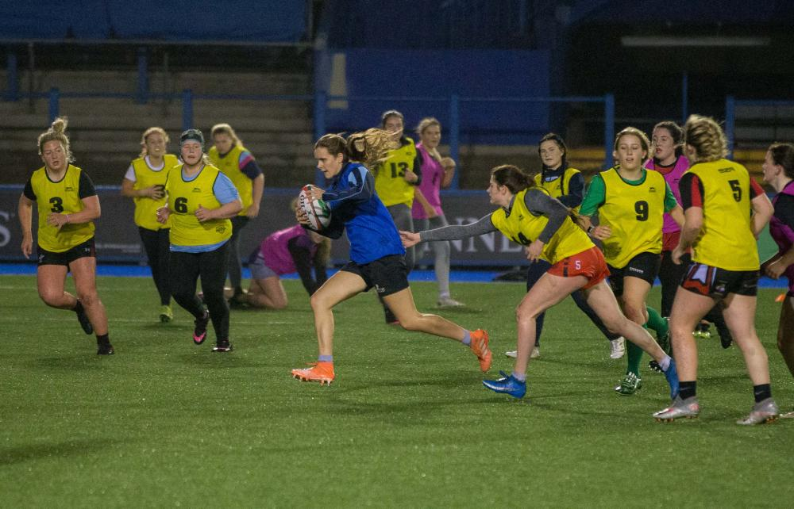
REGIONAL PROGRAMME
Following a hugely successful Skills Development programme and U15 and U18 knock-out competitions during the autumn-winter period so far, a female Under 18 regional training programme will kick-off in all rugby regions in early January.
More than 550 girls from U12s to U18s took part in the eight-week skills programmes throughout the autumn and the U15 and U18 cup and plate competitions have seen 92 games fulfilled to date and a huge increase in participation with the number of teams at this level going from 26 prior to the pandemic to 40 this season.
From the first week of January, twice weekly high performances training sessions will be delivered by regional and WRU staff at five venues around Wales throughout January and February and three regional festivals will take place in February providing invaluable match experience.
The players in the regional squads have been identified by staff and coaches involved in the Skills Development Centres that were held throughout the autumn and based on U18 Cup and Plate performances.
A national U18 squad will then be selected by head coach Liza Burgess at the end of February for international training and playing opportunities.
Head of female age grade, Liza Burgess said, “I’m excited to put plans in place for a Regional training and playing programme leading to an international phase. I’m enthused by what I’ve seen so far, in terms of the standard of rugby I’ve watched, the talent available to us and the commitment of the regions to be full partners in the U18 programme. I can’t wait to start watching U18 training sessions and matches with a view to selecting a national squad.”
WRU Performance Director Nigel Walker said, “This is an incredibly important element of the pathway work being undertaken across the whole of Wales in collaboration with our regional colleagues. The programme provides quality training and playing opportunities for hundreds of girls between the ages of 11 and 18 culminating in the possibility of national representation at U18 level.”
2022 FEMALE HUB SEASON
An extended Female Hub season will begin in February and run through to November 2022. There will be additional playing opportunities both geographically throughout Wales and with extra age groups - teams will be run at U12, U14, U16 and U18 rather than within three-year age groups.
A flexible player-centric pathway will also be introduced in order to enhance skill development, enjoyment of rugby and game understanding. This could include small-sided games, adapted pitch size or Law variations depending on the experience and confidence of players.
Rookie Rugby introductory activities will take place in schools and colleges around Wales throughout the week of February 28 and the first Female Hub festivals are already scheduled for March 6.
MIXED RUGBY AGE
Following extensive consultation, from season 2022/23, it has been decided to lower the maximum age of mixed rugby to under 11.
Insight shows us there is currently a significant drop (50%) in female participation during the season girls move to mixed u12 rugby – which coincides with the start of secondary education. With additional playing opportunities for under 12s within the female pathway, we aim to attract more players to Female Hub teams and retain them for longer within the game.
The amendment to the pathway will come into effect from the registration renewal date in the summer of 2022. Players may continue to play mixed rugby up to Under 13s until the registration renewal date. The age of mixed rugby will then drop to Under 11s for season 2022-23.
WRU Community Lead for Female Game, Joe Davies said, “We are hugely buoyed by the enthusiasm within the female community game, especially within the junior and youth game. The number of teams participating in the U15 and U18 National Cup and Plate competitions is unprecedented, and the commitment of those teams has produced competitive and compelling rugby at every level. With the additional resource for staffing within the female game, we are able to extend the opportunities within next season’s Female Hub provision, in terms of the length of the season, opportunities across Wales and by adding extra age groups. We feel strongly that this will enhance our ability to develop players’ skills, increase their enjoyment of the game and raise playing standards.
WRU Community Director Geraint John added, “A big thanks to all the players, parents, coaches and other volunteers, along with our staff and apprentices for making this past term such a success on and off the field for the female community game. Your work is appreciated and this helps our young players goals to have ambitions and goals.”
For more information on locations of Hubs within the Dragon’s Region contact Ashleigh Jones, Rugby Officer - Female Game (Dragons Region) at ashleigh.collier@wru.wales

