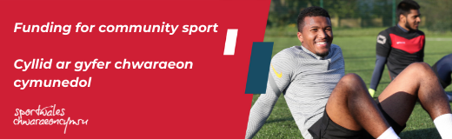

£1 million committed to community projects

Hey All,

Be Active Wales Fund's funding has reached the £1m milestone for this financial year!

We've supported hundreds of clubs become more sustainable, tackle inequalities and take innovative approaches. Could yours be next? Grants of £300-£50,000 are still available.

Apply to ‘Be Active Wales’

Copy the following link not your Browser for all the information.

https://www.sport.wales/grants-and-funding/beactivewalesfund/

